
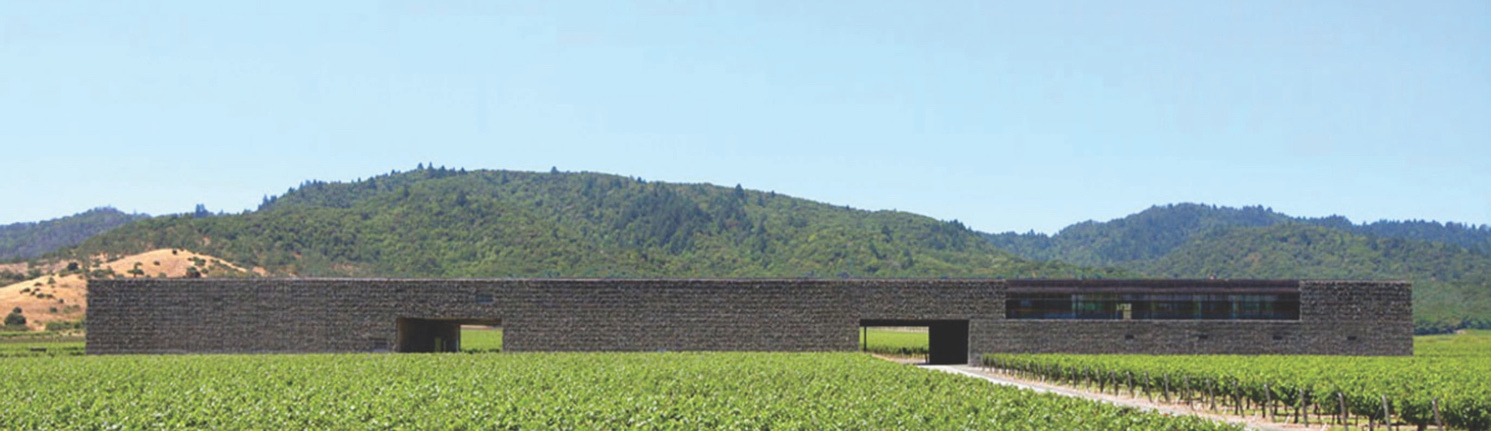

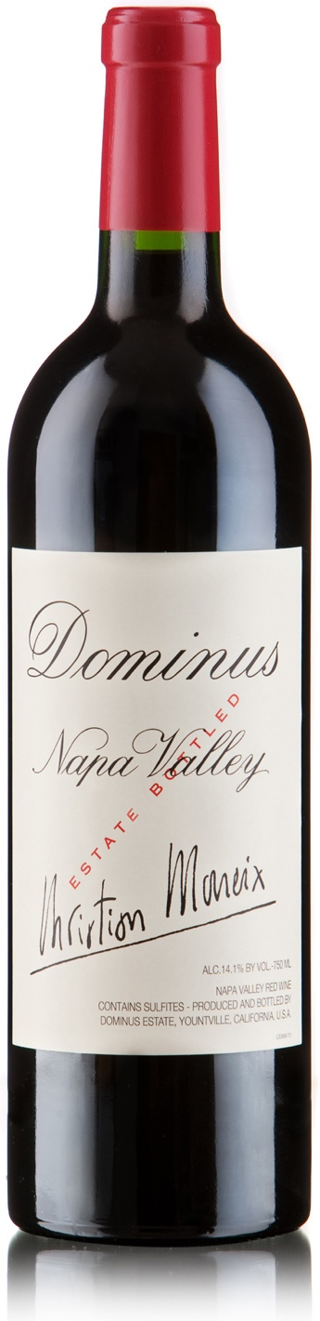
94 pts.
96 pts.

DOMINUS 2006
There are 6,500 cases of the superb 2006 Dominus (91% Cabernet Sauvignon, 6% Cabernet Franc, and 3% Petit Verdot). Its dark plum/purple color is accompanied by aromas and flavors of truffles, forest floor, black cherries, black currants, and Asian spices. One of the finest wines of the vintage, it is complete, full-bodied, and seamlessly built with beautiful ripe tannins, low acidity, and a luscious, layered mouthfeel. The aromatics are even more evolved and complex than the 2005's. The 2006 should drink well for 20-25 years. December 2008

Youthfully floral and tight, this vintage of Dominus is a big wine that holds all of its weight behind a powerful structure. And it's the power of that structure that is front and center-red apple-skin acidity and walnut-skin tannin-needing a ribeye with plenty of fat to bring the fruit out of its cage. Stay with it and the wine's earthiness begins to meld with the blueberry and chocolate richness. But it's all completely primary. Put this away for ten years, and drink the Napanook while it matures. October 2009

DOMINUS 2011
A perfumed and refined nose of rose petal, orange rind, raspberry and coriander flower. This elegant nature continues through the palate, which is lacy and plush, but becomes quite rustic on the finish. Continues to evolve over hours and days, never showing itself the same way twice. Still laying in wait, although perfectly enjoyable now. January 2021

Christian Moueix and his team at Dominus have experience with rainy vintages in Bordeaux. They also farm a site that is particularly well adapted to draining excess water. So they produced a remarkable 2011, a late vintage challenged by rain close to harvest. It’s proof that a challenge met can create something sublime—like this floral, red-raspberry-scented vintage of Dominus. It’s a tense chord of flavor incorporating green herb, tobacco, cassis and raspberry in a lasting harmony. The sophisticated structure suggests it will age with grace, while the gentleness of that structure will make it accessible along the way. A great bottle for lamb. October 2014

LIBRARY VINTAGES OF DOMINUS ESTATE:
2006 & 2011

96 pts.
93 pts.
Exxclusively represented by Maisons Marques & Domaines | www.mmdusa.net

