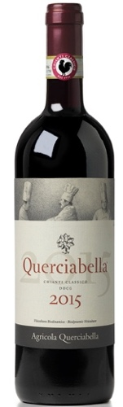
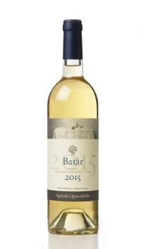
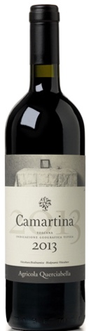
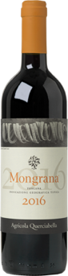


Chianti Classico 2015 | 95 points |
World Wine Awards Platinum Medal | Decanter | February 2018
... represents a giant leap forward in quality for Querciabella– partly the result of the coming-of-age of their plant-based biodynamic viticulture which commenced in 2010... also benefitted from a near-perfect growing season in 2015, and the result is a wine of wonderful purity showing clearly delineated aromas of focused, bright cherry with a hint of leafy freshness, spearmint, raspberries, cream and cinnamon. The palate is beautifully poised, with harmonious tannins, perfectly ripe fruit and bright acidity.

Mongrana 2016 | 95 points | James Suckling | April 2019
Love the aromas of plums, cherries and currants with hints of flowers and undertones of dried flowers. Full body, round and silky tannins and fresh and bright finish. A blend of sangiovese, merlot and cabernet sauvignon. From biodynamically grown grapes and vegan.

Camartina 2013 | 95 points | Vinous | January 2018
... a blend of Cabernet Sauvignon and Sangiovese, all from the Ruffoli sub-zone of Greve. Dense, creamy and beautifully textured in the glass, but in the restrained style that characterizes Querciabella’s wines today, the 2013 is a real winner. Even at this early stage, it’s is all finesse.

Batar 2015 | 93 points | Vinous | January 2018
... very delicate and restrained, especially within the context of the year. Lemon confit, white flowers, orange peel and mint all develop nicely in the glass, but it is the wine’s persistence that stands out most. The 2015 is one of the most polished, gracious Batàrs I can remember tasting.
t
Exclusively imported by Maisons Marques & Domaines | www.mmdusa.net

