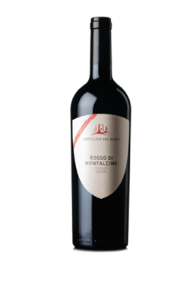
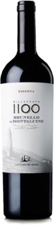
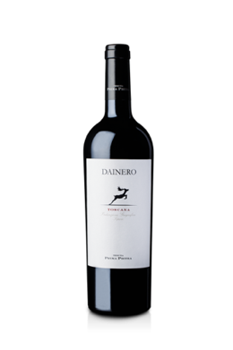
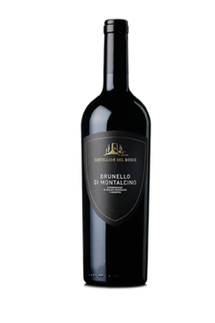

Rosso Cru Gauggiole 2016 | 93 points | James Suckling | April 2019
Shows some really good ripeness on the nose with glazed cherries, dried red plums and caramelized orange peel. Very generous on the palate with round and attractive tannins, framing notes of Christmas cake and chocolate-coated plums.

Dainero 2018 | 92 points | James Suckling | April 2019
Loads of primary fruit showing now, set very much in the essence-zone with cherry compote, violet perfume and blackberry purée. The palate shows good depth and composition...

Brunello Di Montalcino 2014 | 91 points | James Suckling | January 2019
The oak is very assertive here and wrestles savory cedar, meat and spices into red plums. The palate has a juicy, tangy red fruit core and good upfront appeal.

Millecento Brunello 2010 | 94 points + | The Wine Advocate | March 2016
... shows a level of extreme elegance and harmony... the bouquet opens slowly to reveal wild berry, balsam herb and pressed flowers. In other words, the aromas lift gracefully with balanced intensity and buoyancy.

Millecento Brunello 2011 | 94 points | The Wine Advocate | February 2017
The bouquet offers enticing tones of spice and dark fruit... The mouthfeel is extremely polished and fine. This is a very elegant wine that drinks beautifully right now.

Exclusively imported by Maisons Marques & Domaines | www.mmdusa.net

